Task1:

As a user, I want to change my password and/or full name.

|  |  |
| --- | --- |
| Actor | System |
|  |  |
| In  Input data and press update |  |
| Click ok | Display main screen. |

Task 2

As an admin, I want to add a new user into the system.

|  |  |
| --- | --- |
| Actor | System |
|  |  |
| Input data and press add |  |
| Click ok | Display main screen |

Task 3

As an admin, I want to update the type of user into the system.

|  |  |
| --- | --- |
| Actor | System |
|  |  |
| Input data and press update |  |
| Click ok | Display main screen |

Task 4: As a manager, I want to add a new product or update a current product in the system.

|  |  |
| --- | --- |
| Actor | System |
|  |  |
| Input data and press add    Input data and press update |  |
| Click ok | Display main screen. |

5 - As a manager, I want to view a summary report of sales from the system.

|  |  |
| --- | --- |
| Actor | System |
|  |  |
|  |  |
|  |  |

Continuation:

Purchase summary report

System:

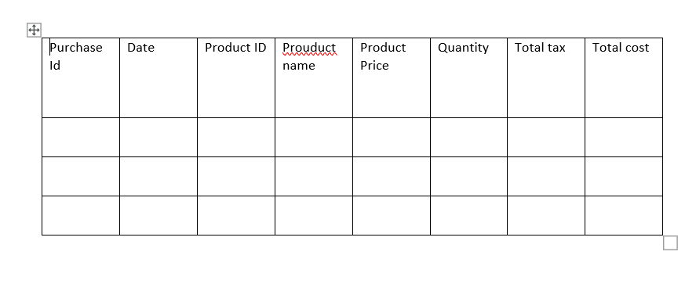

Actor:

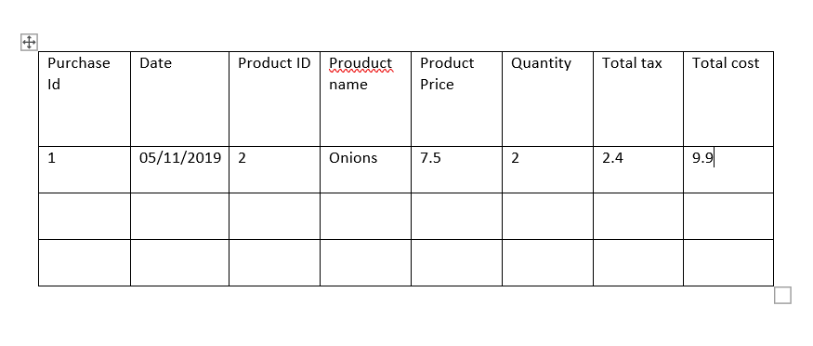

Task 6: As a cashier, I want to add a new customer or update a current customer in the system.

|  |  |
| --- | --- |
| Actor | System |
|  |  |
|  |  |
| Insert data and press add |  |
| Insert data and press update |  |
| Click ok | Display main screen |

7. As a cashier, I want to add a new purchase or update a current purchase (only price and quantity) in the system.

|  |  |
| --- | --- |
| Actor | System |
|  |  |
| Input data and press add |  |
| Input data and press update |  |
|  |  |
| Click ok | Display main screen |

8. As a customer, I want to add a new purchase into the system.

|  |  |
| --- | --- |
| Actor | System |
|  |  |
| Input data and press add button |  |
|  |  |
| Click ok | Display main screen |

Task 9:

As a customer, I want to view my purchase history into the system.

|  |  |
| --- | --- |
| Actor | System |
|  |  |
|  |  |
|  |  |

Purchase History (without data)



Purchase History (with data)



Task 10

As a customer, I want to search for product information (based on name, price) in the system.

|  |  |
| --- | --- |
| Actor | System |
|  |  |
|  |  |
| Input data and press search |  |

|  |  |  |  |  |  |  |  |
| --- | --- | --- | --- | --- | --- | --- | --- |
| Purchase Id | Date | Product ID | Prouduct name | Product Price | Quantity | Total tax | Total cost |
| 1 | 05/11/2019 | 2 | Onions | 7.5 | 2 | 2.4 | 9.9 |
|  |  |  |  |  |  |  |  |
|  |  |  |  |  |  |  |  |